|  |
| --- |
|  |
|  |
|  |

Michael Dick

Prateek Sachdeva

Puja Subramanyam

Project Report

Mobile and Pervasive Computing Services

Spring 2013



Hunger

Tap

**Acknowledgement**

We extend our sincere thanks to Professor Norman Sadeh for all the guidance he has provided us during the development of this project. We would also take this opportunity to thank the TA’s for their insights and helpful tips. We also would like to thank Linda Francona for coordinating our meetings with Professor Sadeh and also providing the necessary hardware required for our project. We are also grateful to friends and other people who took out time from their schedules to provide us feedback on our project either in the form of survey responses or user studies.

Table of Contents

1. Executive Summary 4

2. Motivation 4

3. Business Analysis 5

3.1 Target Market 5

3.1.1 Fast Food Restaurants 5

3.1.2 Coffee and Snack Shops 5

3.1.3 Grocery Stores 6

3.2 Revenue Model 6

3.3 Competitors 6

3.4 Risks 7

3.5 QR Code Market 8

3.6 NFC Market 8

4. Product 10

4.1 User Research 11

4.1.1 Survey 11

4.1.2 Personas 17

4.2 Product Overview 18

4.2.1 Requirements 19

4.3 Paper Prototype 22

4.4 Wireframes 24

4.5 Usability evaluation of the app 26

4.6 Detailed Design 28

4.6.1 Customer App 28

4.6.2 Admin App 39

4.6.3 Web Interface to Manage Orders 40

4.6.4 Development tools 41

4.7 Privacy and security issues 41

4.7.1 User Privacy 41

4.7.2 Security Considerations 42

4.7.3 App Permissions 42

4.8. Future Development 43

5. Conclusion and Learning 44

6. Appendix 45

A. Menu Board Prototype 45

B. QR Menu Board Prototype 46

# 1. Executive Summary

HungerTap is an Android application that is aimed to allow users with ~~NFC enabled~~ smartphones to order their food at a fast food joint or coffee shop in a quick and effective way without standing in any lines. The HungerTap app has two versions. One version caters to users with NFC enabled smartphones and another version caters to users whose phones are not NFC enabled. Hence the app can have a large user base. An admin app of HungerTap would enable restaurant owners to create custom made ~~NFC enabled~~ menu boards with NFC chips or QR codes or both. Customers with the hunger tap app ~~have to tap their phone on the~~ scan or tap items on the menu board that they wish to order. Customers have the option to pay immediately using PayPal or pay later at the counter by cash/card. They are provided the status of their orders to figure out when it is ready for pickup. In this way customers do not have to wait in line just to order their food and restaurants can use their staff to prepare orders. Faster service would mean happier customers and also increased loyalty which would lead to increased profits.

# 2. Motivation

Andrew is a graduate student at Carnegie Mellon University. He has a class every morning at 9:00 am. Being a graduate student, a class at 9:00 am is one where he struggles to stay awake. He needs a cup of coffee to wake him up. He was a regular customer at the Coffee Tree Roasters on Forbes Avenue where he used to pick up his Latte and then catch the 8:50 am bus to college. Recently he started skipping his visits to the Coffee Tree Roasters. Wonder why? The long line at the coffee shop just to order his Latte forced him to go to the coffee shop as early as 8:30 am if he wanted to be on time for class! He landed up waiting for around 10-15 minutes every day just to reach the counter. Once he reached the counter, he would then order his coffee and wait for another 2 minutes to pick up the coffee. Andrew was not the only one waiting here. The people behind him in the line and the staff taking the order also had to wait as there was one staff at the counter taking orders while another staff prepared the orders. This seemed like an utter waste of resources and time. What if both the staff prepared the orders while Andrew could order the coffee himself? HungerTap is the solution here!

Andrew could walk into the coffee shop; use the HungerTap app on his smartphone to order his coffee, wait for just a few minutes and then go pickup his coffee when he is notified that his order is ready. Andrew does not have to wait in line for 10 minutes just to reach the counter to order and also the staff is twice as productive as when compared to the earlier scenario. A happy Andrew would make sure he visits the Coffee Tree Roasters every day to get his morning cup of coffee.

# 

# 3. Business Analysis

## 3.1 Target Market

HungerTap is mainly geared towards self-service restaurants where customers order and pay their food at the cashier first and then pick it up afterwards once it’s prepared. Typical restaurants that operate in this manner are fast food joints, coffee and snack shops, whereas both dine-in and take out restaurants can be served through our product.

This target market is divided into two separate industries, *Fast Food Restaurants* and *Coffee and Snack Shops*.

In addition to these two segments we now also consider the fresh meat, fish and cheese sections in grocery stores as possible target markets. There customers generally have to take a number and wait in line until they are served by the service personnel. Here custom QR codes could be applied next to the products, so that customers can build their order while looking at the actual product. Afterwards the order is prepared while the customer can continue to shop and pick it up before the checkout.

### 3.1.1 Fast Food Restaurants[1]

In the fast food industry there are 149,052 businesses that generate revenue of $191bn. These businesses operate 232,611 establishments throughout the US. Franchised and multi-establishment operators account for only 10% of the market, however make up 65% of total revenue.

Overall it’s a low margin business so that operators have to be cost conscious. IBISWorld identifies having high profile locations as one of the key success factors, which are tied to high costs. One way of mitigating these higher costs is increasing the customer throughput.

### 3.1.2 Coffee and Snack Shops[2]

The Coffee and Snack Shop Industry consists of 38,868 businesses with revenues of $27.8bn, whereas coffee shops make up the majority of the market with a share of 42%. 60% of the market consists of the top four players in the industry. Overall there are 57,509 establishments in the US.

We want to focus on small business restaurants first, that usually don’t have the financial power to implement more sophisticated order systems. Our solution provides a low cost alternative that supports the ordering process. Looking at these two industries, our market is $78bn.

### 3.1.3 Grocery Stores[3]

The Supermarkets and Grocery industry in the US consists of 35,583 businesses with 64,063 stores and $517.8bn of revenues. The three largest players in the market make up roughly 30% of the entire market. The largest share of revenues for stores does actually come from fresh and frozen meat which also includes poultry, fish and deli items and which is expected to increase over the next years.

One major cost driver for stores are labor costs from their employees. Therefore we feel confident that stores are interested in finding alternate solutions of servicing customers at these labor intensive counters while ensuring customer satisfaction.

## 3.2 Revenue Model

We want to drive adoption by making the product readily available for customers as well as restaurant owners. For us the marginal cost of adding another customer or another business is close to zero, especially in the beginning. Therefore we plan to offer the app for free to customers to quickly build a critical mass and possibly pulling the solution into the market from the customer side, where customers would prefer restaurants that offer our solution.

For the restaurant owners we also want to set the barrier to try out the service low. Therefore we offer 20 orders per month for free, so that their trial costs will be only the NFC chips and new menu layout as well as a limited time investment. For owners that receive more than 20 orders through our product, we will start charging a transaction fee of 3% of all order revenues. We think that this will drive adoption and we will be able to sustain the service, due to minimal operating costs. At a market size of $78bn this gives us a total addressable market of $3.9bn.

For grocery stores a monthly flat fee is more appropriate. Due to the low margin nature of their business they need to be able to plan their cost structure accurately. This price structure would require providing the stores with a free trial period to provide proof of the value of our solution.

## 3.3 Competitors

Our service covers the restaurant order, payment and notification process that is currently served by up to three different products besides manual labor. For taking the order most restaurants use a cashier that manually records the order either in person or over the phone. Additionally some restaurants have websites in place that include an online ordering mechanism.

For smartphones there exist a variety of apps such as GrubHub or Eat24. These apps use online menus from which the user can choose their food and then pay through the app. Usually they don’t require the user to be present at the restaurant, so that they can also be used for delivery restaurants.

On the pure payment side there are apps such as Square or Google Wallet that allow customers to pay through their service. The services use various methods to authenticate the user and process the payment.

Lastly some restaurants have third party notification systems that notify the customer when their food is ready. These require special hardware thus making them not as attractive to smaller restaurants.

For grocery stores our solutions compete directly with the manual labor they are currently using to service customers. We would provide an alternative way for customers to select their products and service employees could focus on preparing the orders for pickup.

## 3.4 Risks

The success of our product is based on certain assumptions that come with risks, we want to mitigate.

Current market analysis estimates the number of NFC devices to rapidly grow over the next years. There are signs in the market that the adoption rate is actually increasing such as more and more recent handsets include the technology. Also big companies such as Google are heavily investing in services that rely on NFC technology, such as Google Wallet. In the end however only time will show if the technology will find broad adoption. We acknowledge this as one of the main risks that will decide the success of our service in the market. ~~Therefore we want to focus on looking into alternative options besides NFC to offer a comparable user experience without relying on just one technology.~~ We mitigate this risk, by offering the application with QR code support as an alternative. Every recent smart phone does have a camera good enough to scan QR codes. Even though with QR codes as well, there is a risk of user acceptance of the technology, it is significantly lower than with NFC.

Besides technology our success relies on the adoption of our service by restaurants as well as users which form the two sides to our market. As adoption on either side increases, the service becomes more attractive to the other side. For restaurants the service might add too much overhead. A restaurant might change their menu quite frequently which would add the need to reprogram the NFC menu every time. Also the restaurant might already have an order management system in place as part of their Point of Sales (POS) system. Therefore they might not necessarily have another computer in place to run our service. On the customer side it requires the user to download the app which might be a hurdle to some users. Also some users might prefer the personal interaction with the store personnel over using an app.

## 3.5 QR Code Market

The quick response code (QR code) is a matrix type barcode used to store data and make it machine readable. Today QR codes can be read by any camera enabled smartphone. It’s already in use in a variety of different applications such as marketing, data sharing or actually virtual stores.

In June 2011, 14 million mobile users in the US scanned QR codes and the user recognition is growing.[4]

## 3.6 NFC Market

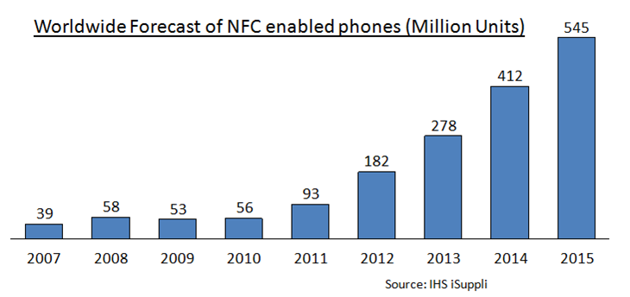

Figure 1: Worldwide Forecast of NFC enabled phones

* 53 Percent of Phones would be NFC-enabled by 2015.[5]
* America is currently the largest contributor of revenue to the NFC market. This trend is expected to continue. [6]
* The acute increase in smartphone users has created an environment for greater NFC awareness among customers. 6
* Furthermore, customer mentality for greater convenience in this region is expected to drive the adoption of the technology. 6



Figure 2: NFC Market revenue forecast in the US.

* The figure above clearly shows the increasing revenue forecast in the NFC market.

Looking at the predictions, NFC technology will definitely catch up in the future.

# 

# 4. Product

There are many ways food can be ordered at a restaurant. We first started out by listing the ways we could think of and identifying the advantages and disadvantages of each of those methods.

|  |  |  |  |
| --- | --- | --- | --- |
| **Sl No.** | **Method** | **Advantages** | **Disadvantages** |
| 1 | Cashier/Waiter | -Default way of ordering.  - Does not require users to have a smartphone. | - Possibly more expensive in terms of labor cost.  - There could be a line to order. |
| 2 | Touch screen/ KIOSK | - Users are familiar with the technology.  - No extra effort required on user side.  - Does not require users to have a smartphone. | - Requires more investment from restaurant owners to purchase a touch screen and also spend on its maintenance.  - There could be a line to access the KIOSK. |
| 3 | QR codes/Bar codes | - Cheap | - User needs to photograph the code. - - Takes longer and requires more effort from the user.  - Good lighting required. |
| 4 | Web page/ web menu based types | - User need not be present in the restaurant to order.  - Phone does not need to be NFC enabled. | - Navigating the menu on the small screen of the smartphone could be hard. The menu can be cluttered and may be inconvenient to navigate.  - Since, users need not be in the restaurant to order, malicious users could randomly order online and not show up to collect the food.  - Menu download could consume a lot of data. |
| 5 | Chinese way of entering numbers | - Easier to key in numbers than selecting from a cluttered online menu.  - Cheap. | -Requires manual user input.  - Malicious users could randomly order and not show up to collect the food. |
| 6 | NFC | - Easy to tap and select  - Fast and requires less effort  - No Wi-Fi/3g required for menu. Only payment requires Wi-Fi/3g which means less data transferred  - Something new, people could be curious to try | - Rewriting NFC tags if menu changes. However some form or re-working is also required in other methods if the menu changes.  - Phone may not be NFC enabled. |

From all the options above, we boiled down to a few - using NFC’s, using QR codes, the Chinese way of entering numbers or the web based menu option. We decided to use our user survey to decide which would be the best way that users would like to use.

## 4.1 User Research

### 4.1.1 Survey

An initial user survey was conducted to understand whether our motivation scenario was common or was it just a one off case and also to understand what kind of solution users preferred. We based our design and feature list from the results of the survey.

|  |  |
| --- | --- |
| **Survey Summary** |  |
| **Number of users surveyed** | 47 |
| **Age-group** | Most of the respondents were between 22-30 years |
| **Occupation** | Most of the respondents were students or working professionals |
| **Medium used to survey** | Online – Survey link was shared on Facebook or via email |

**Q1: How often do you land up waiting at a food joint/coffee shop just to place your order?**

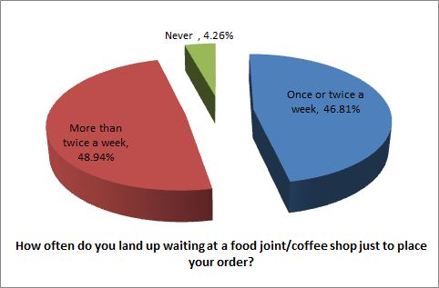

**Inference:** 96% of respondents waited in line at least once or more number of times in a week. This clearly shows that our motivation was not a one-off scenario. A good number of users do land up waiting in line at a food joint just to order their food.

**Q2: At a food joint/coffee shop, given an option to not wait in line for ordering which of the following methods would you choose to order your food?**

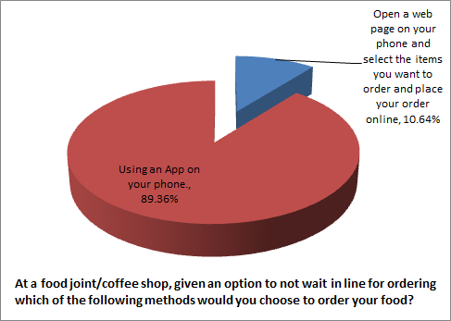

**Inference:** The results of this question were important for us. From the various methods that one can order on the smartphone, we were contemplating if using an app would be preferred by users or would they prefer ordering from a web page. The answers clearly supported us in our thought that creating an app for ordering would be better than opening a web page and ordering.

**Q3: Given that you have an app to order, how would you prefer to enter your order?**

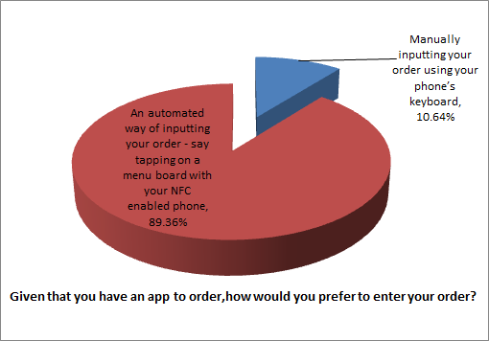

**Inference:** The previous question clearly showed us that having an app is the right way to go. But amidst using apps as well, there are many ways of ordering like having a Chinese menu way of ordering where the user can input the “code number” of the item he/she wishes to order. The results of this question showed us that users would not want to manually type in anything. The best way we could think of automating user input is by using NFC’s.

**Q4: Would you order using an NFC based app - you would have to tap your NFC based phone on a menu board to select your order?**

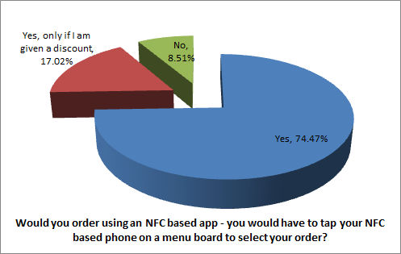

**Inference:** 91% of users were willing to use an NFC based app. This seems like a good sign.

**Q5: Which of the following payment options would you prefer?**

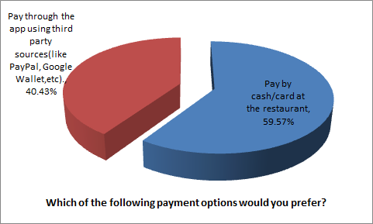

**Inference:** The initial plan was to automate the payment by including third party sources like PayPal. The response to this question showed us that most people still prefer the traditional method of paying by cash/card. To cater to this set of people, we decided to give two payment options in our app. Those interested in paying with PayPal could pay immediately while those wanting to pay by cash/card could pay at the counter after placing their order.

**Q6: Do you have an NFC enabled phone?**

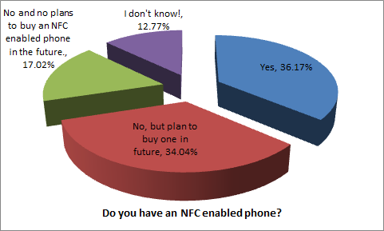

**Inference:** This question indicated mixed responses. 18% indicated that they had no plans to buy an NFC enabled phone. We decided that we would provide an alternate way of ordering for phones which are not NFC enabled. Since 91% of respondents showed interest in using an NFC based app, we decided that we would concentrate on working with the NFC part for the first half of the semester and look at alternate ways during the second half of the semester. This way, we could cater to a larger segment of the market and not only for those with NFC enabled phones.

For the second half of the semester, we decided to consider QR codes and the Chinese method of entering numbers as our possible choices for the non-NFC based segment of customers. We chose not to do a web menu based approach in order to reduce the amount of data the app uses and also our idea was to target markets where people were in the store while ordering. For example, a store can lay out samples of what they have to sell along with a QR code/a number against it. Customers can look at the product and then decide which to buy.

We conducted a user test and survey to decide which method to finalize on.

**Experiment performed to evaluate menu selection using QR code and Chinese method**

The rationale behind this experiment is to identify which of the two methods was better for users to order food. We wanted to compare the time taken by users to order food in the two methods and also ask users which method they preferred. The only thing different in the two methods is how the method of order input. Hence this was the only thing we measured in our user test.

**How the tests were conducted:**

We created two apps for this user survey.

* One app for the Chinese method
* One app with the QR code method

The main reason we did not do the user test with a paper prototype is because we would not be able to evaluate the exact time required to scan the QR codes or how much time users took to input the data. Since the rationale for our evaluation was to identify the time taken by users, we had to develop prototype apps for the test.

Note: We needed check-in functionality in the Chinese method to identify user location to figure out which restaurant the user was in. This was needed to identify which restaurant was to receive the order. This identifying information was included in the QR codes but for the Chinese method a Check-in was required. The Check-in functionality in the Chinese method app was not implemented. Users were just expected to click OK on the check-in dialog.

**Task Script:**

Chinese Menu: First Check-in and identify the restaurant you are in. Then select any 3 Items from the given menu that you wish to order.

Menu with QR codes- Select 3 items that you wish to order.

**Survey Result:**

|  |  |  |  |
| --- | --- | --- | --- |
|  | **Time taken using**  **Chinese Method**  **(in seconds)** | **Time taken to select**  **items by scanning**  **QR codes (in seconds)** | **Method preferred? Chinese**  **or QR** |
| Subject-1 | 40 | 44 | QR |
| Subject-2 | 73 | 51 | Chinese |
| Subject-3 | 61 | 37 | QR |
| Subject-4 | 71 | 50 | QR |
| Subject-5 | 80 | 35 | QR |
| Subject-6 | 75 | 49 | Chinese |
| Subject-7 | 62 | 43 | QR |

Average Time taken to select items using Chinese Method: 66 seconds

Average Time taken to select items by scanning QR codes: 44.14 seconds

Percentage of people who prefer QR method: 71.4%

**User comments:**

**1. Chinese method:**

One user felt that there were too many buttons. He wanted the item code and quantity input to me on the main screen rather than a new dialog.

Most users took time to swap between the alphabet and numeric keyboard.

Three users made a mistake while inputting the code and hence had to erase it and retype.

One user who preferred the Chinese method had a hard time scanning the QR code. Hence he preferred the Chinese method.

**2. QR code method:**

One user had difficulty in scanning but still preferred QR over the Chinese method.

One user said he strongly preferred the QR code method as he was happy not having to type any input.

**Additional Learning from the user study:**

Though this study was meant to identify the time taken in the two methods, one user suggested to us to include quantity increase and decrease buttons on the UI because he did not want to scan the item again. This was one thing we had not come across during our initial user studies. Hence we also included +, - and x symbols for every item so that users can increase or decrease quantity or delete the item instead of re-scanning the item.

### 

### 4.1.2 Personas

**Customer**

Name:Andrew Carnegie

Age: 25

Profession: Student

Andrew is a graduate student at Carnegie Mellon University. He has a class every morning at 9:00 am. Being a graduate student, a class at 9:00 am is one where he struggles to stay awake. He needs a cup of coffee to wake him up. He is a regular customer at the Coffee Tree Roasters on Forbes Avenue where he picks up his Latte and then catches the 8:50 am bus to college. In between classes he usually grabs a quick lunch at one of the food trucks on campus or the hot dog cart. After classes are over he works out at the gym before he returns home to work on his homework.



**Store Owner**

Name: Susan Griffin

Age: 38

Profession: Coffee Shop Owner

Susan owns a coffee shop in Shadyside. She works there herself most of the time but has some college students that help her out. Traffic at the store varies a lot during the day. There is a rush of business people coming in before work between 7.30-8.30am when a long line forms at the cashier. Then it’s quiet until lunch time when people in their lunch break come over. During the day she spends time on her laptop while the customer traffic is lighter.

## 4.2 Product Overview

Initially we had first thought that ~~restaurant owners~~ vendors can email us their items and prices and we would write the NFC tags for them and ship it to the ~~restaurants~~ vendors. The advantage of this method is that the ~~restaurant~~ vendor will not have to worry about writing on to the NFC tags. The disadvantage is that the shipping takes time and every time the price changed, they would have to contact us thus delaying the process for them. Therefore we decided to create an admin app for ~~restaurant owners~~ vendors that they can use to write on to the NFC. This admin app also allows vendors to generate QR codes for the items on their menu as well. The QR code can be emailed to the vendor which he can use to create his menu.

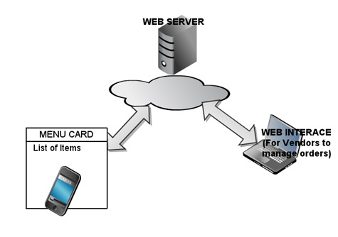

Figure 3: Architectural overview

The business solution consists of multiple components:

1. Client App

This app is installed on the phone of the customers who buy from the vendors like Starbucks etc. The clients use this app to choose items from the menu and place the order by choosing either to pay at the counter or pay via PayPal account. We have 2 client apps. One app for is specially targeted for phones with NFC capability and another app for smart phones with cameras to read the QR codes.

1. Admin App

This app is used by the vendors like Starbucks to write item-details onto new NFC tags or to update existing NFC tags in use. The admin app also allows vendors to generate QR codes for their items and email it to themselves.

1. Webserver

The Web-Server manages the databases of the items listed by each vendor and orders placed by the clients. It also takes care of the authentication and login from vendors. It provides web-interface to the vendors to manage orders. Details are explained in the subsequent parts.

1. Menu-Card with embedded NFC tags and/or QR codes

The Vendor needs to stick the NFC tags onto the menu - card or menu - board once the NFC tags have been written. The vendor can create one menu with both NFC tags and QR codes or creates only the QR code menu or only the NFC menu based on his needs.

A more detailed architecture is described in later sections.

### 4.2.1 Requirements

Based on our user research we built a list of requirements and prioritized them (0=high, 1=medium, X=cancelled) based on what would be our minimal viable product (MVP). For most use cases we first started with a number of different alternatives of accomplishing a task and then chose the most appropriate one based on our survey, user interviews and technical feasibility.

As we worked through the requirements we marked the chosen alternatives in **green** if there were more than 1 option. In the initial prototype we only considered requirements with priority 0.

|  |  |
| --- | --- |
| **Priority** | **Use case**  **Customer App** |
| **1** | **App Installation (NFC enabled phone)**  A user opens the Play Store on his NFC enabled phone and searches for HungerTap. He selects the app from the search results and hits the Install button to install the app on his phone. After confirming the permissions, the app is installed on his phone.  *Alternative 1:* The user clicks on a link on the restaurant’s web page with his phone browser which opens the app’s page in the Play Store  *Alternative 2:* The user scans a QR code which opens the app’s page on the Play Store  *Alternative 3:* The user taps his phone on a NFC chip which opens the app’s page on the Play Store |
| **1** | **App Installation (non NFC enabled phone)**  A user opens the Play Store on his non NFC enabled phone and searches for HungerTap. He selects the app from the search results, but the install button is greyed out. There is a message that the app only works with NFC enabled phones.  *~~Alternative 1:~~* ~~Include a Non NFC based solution in the app. TBD later.~~  *Alternative 1:* Create another app with a Non NFC based solution – QR codes. |
| **0** | **Running the App**  The user selects the HungerTap app from his apps. The app polls the user’s location and selects the restaurant he is currently located at.  *Alternative 1:* Once the user taps a location identification NFC tag, the app recognizes which restaurant he is in.  *Alternative 2:* The user can manually search for the restaurant he is in by address or name.  Alternative 3: Have the location id embedded in every NFC tag on the board. |
| **0** | **Order (NFC enabled phone)**  The user opens the app and is brought to the Home Screen. A message tells him to start tapping on the menu. There is a button to check out the order at the bottom of the screen.  If an item is tapped, it is added to the end of the order list with the quantity and price. A total price is calculated at the bottom. If the list grows longer than the screen it is scrollable. If a user taps an item twice the quantity is increased by one. The user can press the + and – buttons to increase or decrease quantity and x to delete the item.  If the user selects to finish the order he is taken to the checkout page.  Alternative 1: Instead of pressing the checkout button the user can tap a special tag on the board, marked checkout. |
| **1** | **Order (non NFC)**  ~~TBD based on which methodology we would use for non NFC based ordering.~~  The user opens the app and is brought to the Home Screen. He clicks on “Scan item”. A camera view opens up. He can scan the QR code and then when the code is read, he is brought back to the home screen with the item updated in the order list. The user can press the + and – buttons to increase or decrease quantity and x to delete the item. He can also scan the QR code again to increase the quantity. When a user clicks checkout, he is taken to the checkout page. |
| **0** | **Checkout**  The checkout page offers the user the choice of method to pay. After the payment process is completed an order number is displayed for the user  Alternative 1: There is an option to pay by cash/credit card  Alternative 2: There is an option to pay through PayPal  Alternative 3: There is an option to pay through Amazon checkout  Alternative 4: There is an option to pay through in-app payment. (We did not choose this as Google takes a 30% cut). |
| **0** | **Pay by PayPal**  The user is brought to the PayPal login where he logs into his PayPal account. After going through the PayPal payment flow he is brought back to the Checkout page where the order number is displayed. |
| **0** | **Pay by cash/card**  Using the order number as reference, user can proceed to a cash register to pay. |
| **X** | **Restaurant Emails**  Once a user has completed an order, an email with the order details and order number is generated and sent to a predefined email address.  (Server and database polling implemented instead) |
| **0** | **Ready Notification**  The customer is notified through a push notification once his order is ready  Alternative 1: A user can request a status update manually.  In addition to this, the user receives push notifications when the order is ready. |
|  | **Restaurant Admin App** |
| **0** | **Home Screen**  Once the user opens the app he is prompted to login with his credentials. There is also an option to sign up for the service |
| **0** | **Signup**  The signup screen prompts the user for the following information:  Name, Address, Phone, Username, Password |
| **0** | **Write to NFC Tag/Generate QR**  The screen prompts the user for the item name and price and allows writing to an NFC tag or generating a QR code. The user gets a confirmation that the data is written to the tag. |
| **1** | **Email QR**  This screen displays the generated QR code for the item based on the user’s input. The user is given an option to email the QR code. |
|  | **Restaurant Web App** |
| **0** | **Home Screen**  The main screen has a login and an option to sign up for the service |
| **0** | **Order Overview**  Once the user has logged in he is shown the order overview. As new orders come in they are displayed in the list. Each order has a button to mark it as paid and mark it as ready. If a user has paid through PayPal, the paid button is disabled. |

## 4.3 Paper Prototype

**4.3.1 HungerTap App**

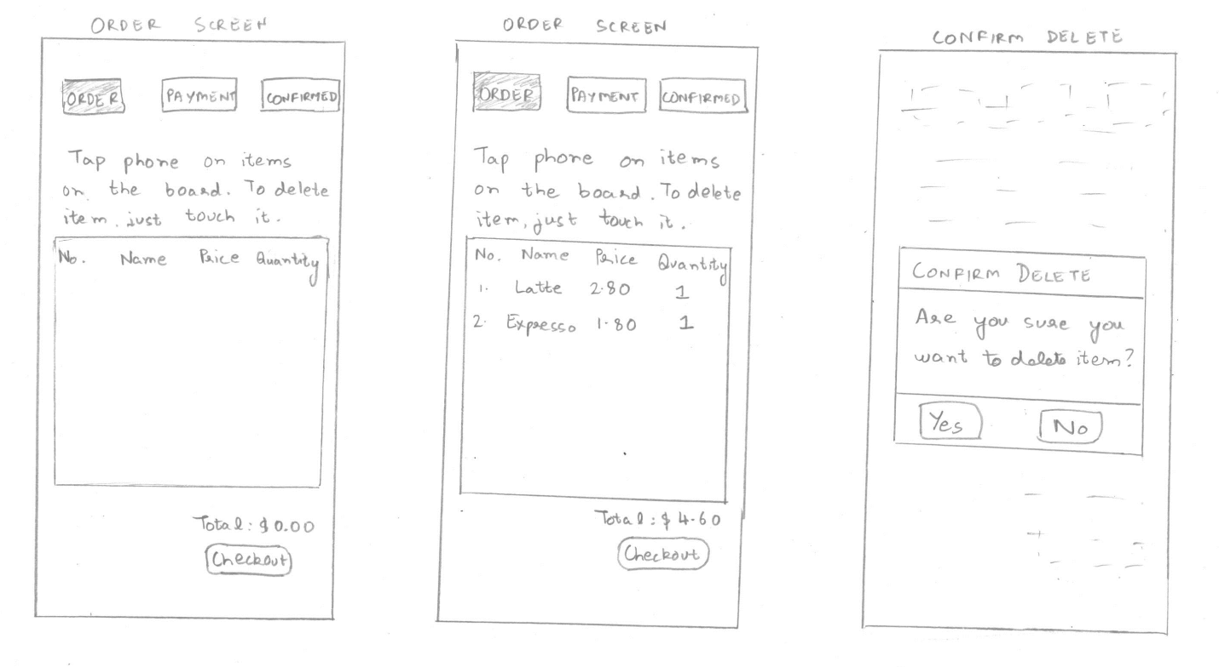

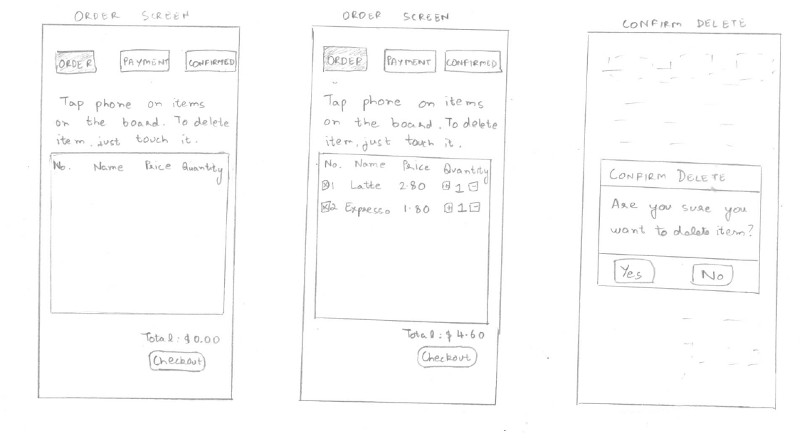

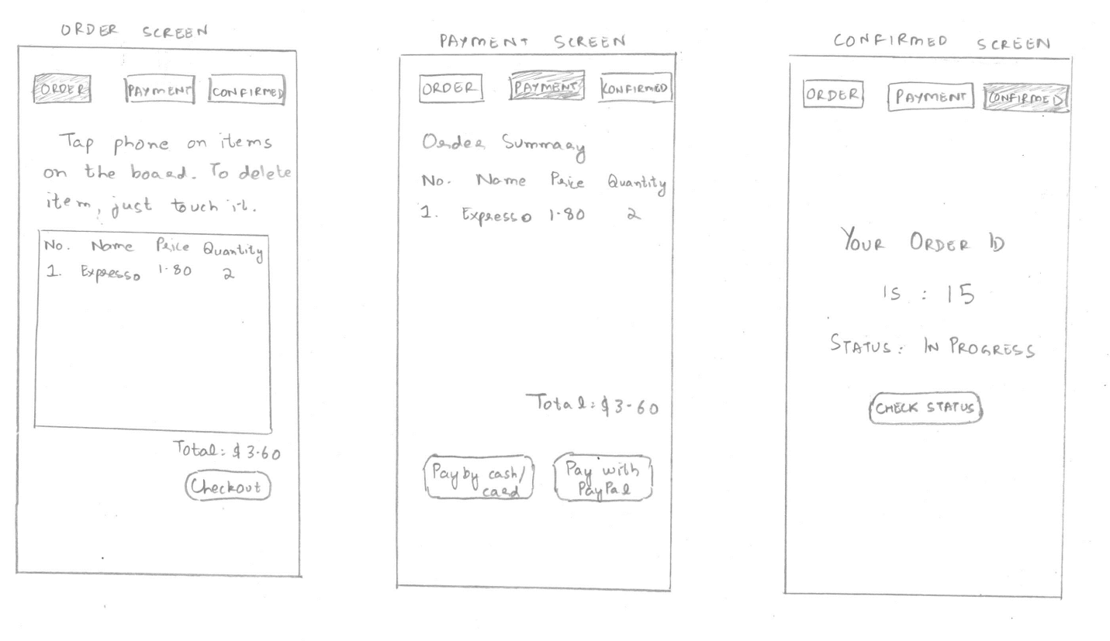

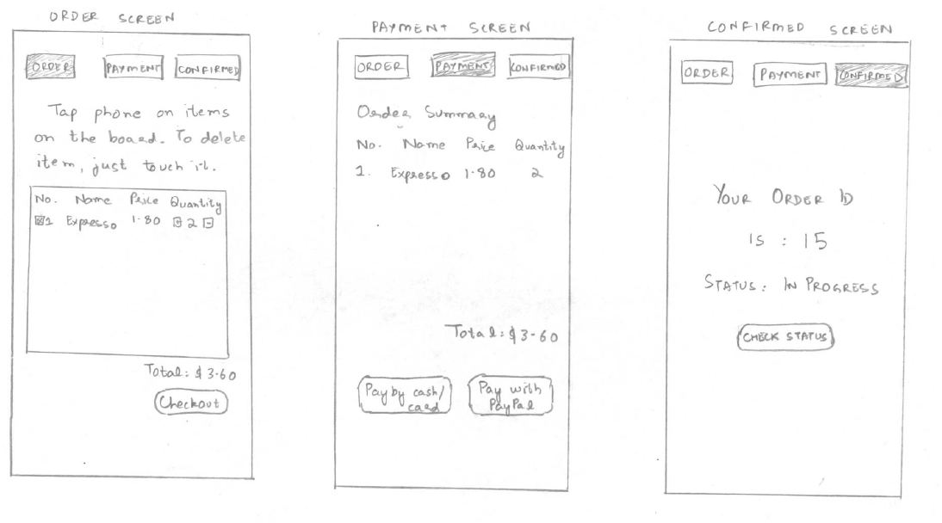

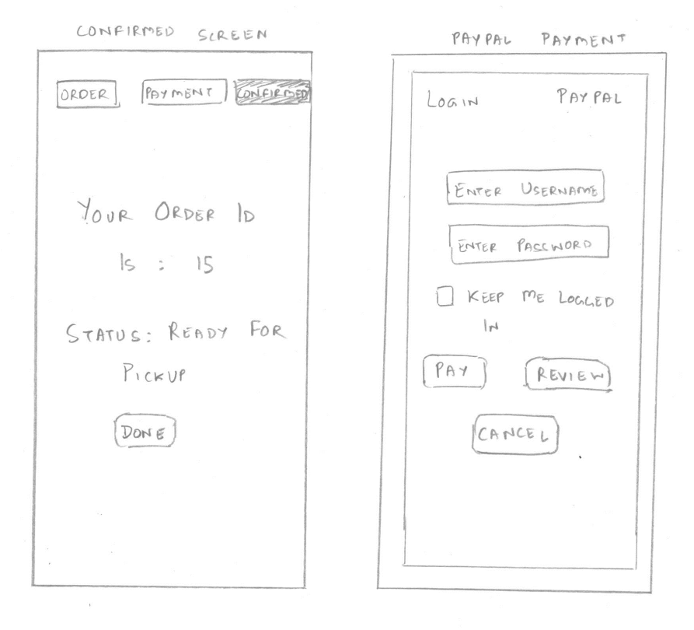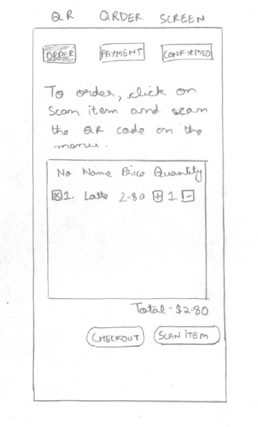

Figure 4: Paper prototype of the various screen of the app

**Usability Evaluations of paper prototype of the NFC app**

In this evaluation, we would place our paper prototype in front of a user and direct the users about what to do using the script below. We have tried to be least specific in the terms used in the script to understand if users can navigate through our app or not.

**Script:**

Open the HungerTap app and choose to order a Latte and an Espresso.

You have changed your mind and want to order two Espresso’s instead.

Complete your order. We have dummy PayPal credentials pre-configured on the app if you choose to pay with PayPal.

**Interviewee #1**

**Description of user:** Female student aged 24 years. She is a smartphone user for about 2 years now.

**Interview description:**

HungerTap: Open the HungerTap app and choose to order a Latte and an Espresso.

User Action: User opens the app and pretends to tap the prototype on the menu board. But she taps the font of the phone prototype at right angle to the menu board. Obviously this is not how it is done.

HungerTap: That is not how you tap the phone. Please tap it like this. (shows how to tap).

User Action: She then taps on the Latte and the Espresso.

HungerTap: You have changed your mind and want to order two Espresso’s instead.

User Action: The user read the instructions on the screen and touched the Latte. The user then clicks on Yes on the popup dialog for confirming delete. She then pretends to tap on Espresso. The count of the Espresso increases to 2.

Hunger Tap: Complete your order. We have dummy PayPal credentials pre-configured on the app if you choose to pay with PayPal.

User Action: User presses checkout. Then the user presses “Pay by cash/card”. The user is surprised to reach a screen which shows the order id and instructions saying that the user has to pay at the counter.

User: I thought the app was giving me an option to input my credit card details here and pay online.

HungerTap: Oops, we did not mean that. We meant you can pay later at a register by cash/card.

User Action: User presses “Check status”. The status message changes to “Ready to pick up”. User presses “Exit”.

**Evaluation Feedback Analysis**

|  |  |  |  |  |  |  |
| --- | --- | --- | --- | --- | --- | --- |
| Sl No | **Prototype Screen** | **Line number** | **User’s feedback/ critical incidence/ problem** | **Reason for negative feedback / breakdown** | **S Severity**  ( High/ Medium/ L Low) and  **Justification** for giving it that rating | **Way(s) to rectify** |
| 1 | Order screen | 3 | User tapped the phone at right angles to the menu board. The NFC cannot be read this way. | The user does not know how to tap on NFC’s. | High - Our app is useless if the user does not know how to tap the phone. | Show an initial popup/help screen with a picture on how to tap the phone on the NFC. |
| 2 | Payment screen | 16 | The user thought that pay by credit card meant inputting credit card details and paying online. | The “Pay by cash/credit card” could be a misnomer for users | High- It could convey a wrong idea to users | Rename the button to “Pay at register”. |

**Interviewee #2**

**Description of user:** Male professional working in the IT industry aged 30 years. He has been using a smartphone for about 8 years now. The user is a regular PayPal user.

**Interview description:**

HungerTap: Open the HungerTap app and choose to order a Latte and an Espresso.

User Action: User opens the app and pretends to tap the prototype on the menu board. He taps on the Latte and the Espresso.

HungerTap: You have changed your mind and want to order two Espresso’s instead.

User Action: The user touched the Latte on the screen and then presses Yes on the popup dialog for confirming delete. He then pretends to tap on Espresso. The count of the Espresso increases to 2.

User: Maybe you can have a popup dialog here as well confirming if the user wants to increase the quantity.

HungerTap: Okay. Thanks, we will implement the suggestion.

Hunger Tap: Complete your order. We have dummy PayPal credentials pre-configured on the app if you choose to pay with PayPal.

User Action: User presses checkout. The user then tries to press on “Order” to go back to the order screen.

HungerTap: We had initially considered these icons as status icons showing the progress in order and not as buttons. But we will change them to Buttons to let you navigate back to Order here.

User: Okay

User Action: Then the user presses “Pay by PayPal”. The user inputs the dummy username and password provided and clicks on Pay. The user reaches the confirmation screen.

User Action: User presses “Check status”. The status message changes to “Ready to pick up”. User presses “Exit”

**Evaluation Feedback Analysis**

|  |  |  |  |  |  |  |
| --- | --- | --- | --- | --- | --- | --- |
| Sl No | **Prototype Screen** | **Line number** | **User’s feedback/ critical incidence/ problem** | **Reason for negative feedback / breakdown** | **Severity**  (High/ Medium/ Low) and  **Justification** for giving it that rating | **Way(s) to rectify** |
| 1 | Order screen | 8 | Include a confirmation dialog for increasing quantity of items | Currently no such dialog exists and a user may not know if he has accidentally increased the item count. | High-It is important that the user is aware of the increased count | Include a popup confirmation dialog. |
| 2 | Payment screen | 16 | The user thought clicking on “Order” would take him to the order screen. | We had initially thought to have the top 3 are just icons indicating current status and showing the progress in order. We realized that we should allow the user to navigate back to “Order” screen if he wants to add more items. | High- The app should allow users to navigate back to order screen. | Change the icons to buttons. |

A separate usability evaluation of the QR app was not done as the screens of both the apps are the same except for how the order is taken as input. To test the order input for QR, a user test was done which is described earlier.

**4.3.2 Hunger Tap ADMIN App Paper Prototype**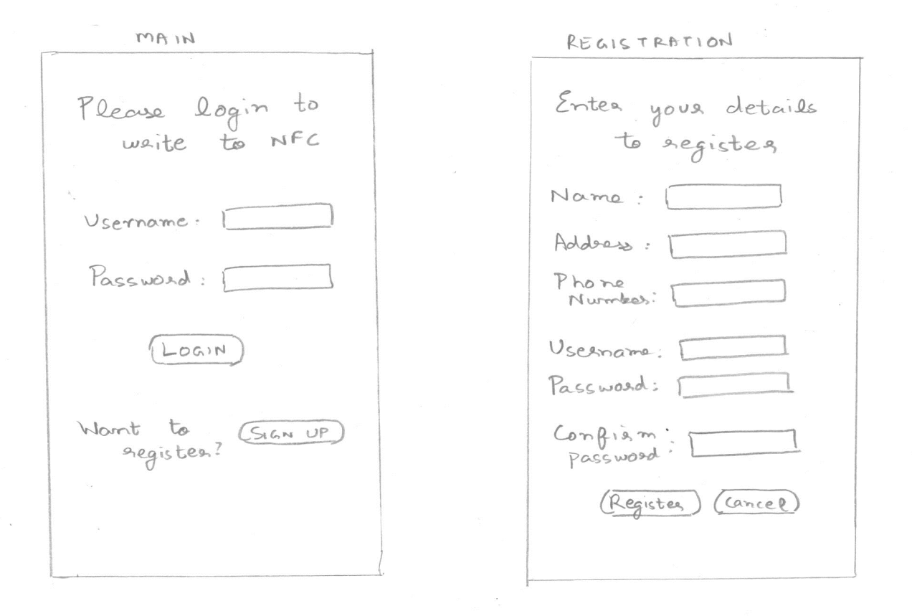

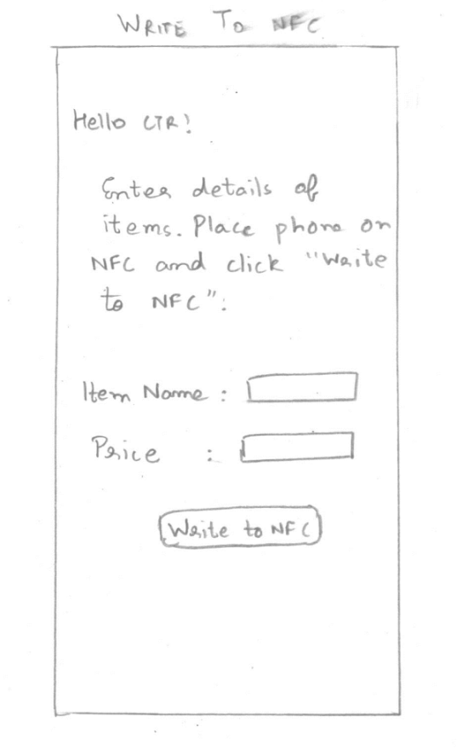 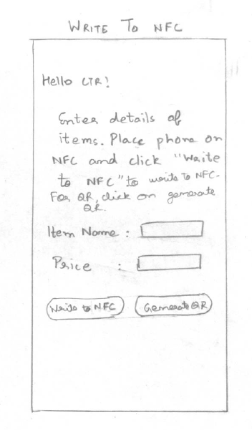

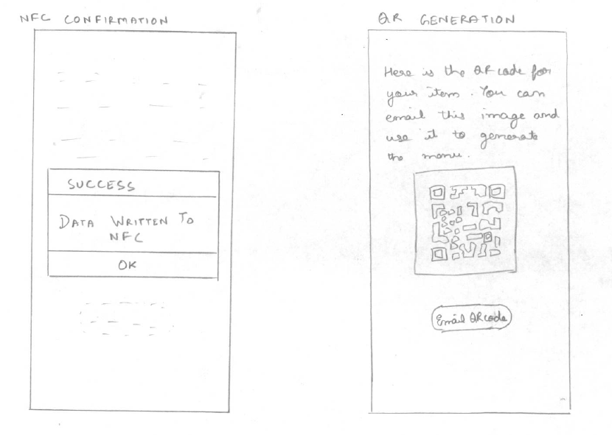

Figure 5: Paper prototype of the HungerTap admin app

**Usability Evaluations of paper prototype of admin app for writing to NFC**

The script for evaluating the admin app is very simple. It was a one line instruction which said:

Open the HungerTap admin app and write details of Latte costing $2.80 on to the NFC.

**Interviewee #1**

**Description**: Female student aged 27 years. She is a smartphone user for about 3 years now.

**Interview description:**

HungerTap: Open the HungerTap admin app and write details of Latte costing $2.80 on to the NFC.

User Action: User opens the app and presses on sign up. The user pretends to input all the required details and presses register. The user is taken to the screen where she has to type the item name and price. She types in the name and price and pretends to place the phone on the NFC and then presses on “Write to NFC”. A popup dialog appears that the user has successfully written the data on the NFC.

**Evaluation Feedback Analysis:** No issues found

**Usability Evaluations of paper prototype of admin app for generating QR**

Script: Open the HungerTap admin app and generate a QR for a Latte costing $2.80. Email the QR code to yourself.

**Interviewee #1**

**Description**: Male student aged 26 years. He has been using a smartphone for a year now.

**Interview description:**

HungerTap: Open the HungerTap admin app and generate a QR for a Latte costing $2.80. Email the QR code to yourself.

User Action: User opens the app and presses on sign up. The user then pretends to register and clicks on “Register”. In the next screen the user types the item name and price. He then presses the “Generate QR” button. The next screen with the QR and the “Email QR” button is displayed. He then presses Email QR.

**Evaluation Feedback Analysis:** No issues found.

### 4.4 Wireframes

Based on our paper prototypes and user interviews we made improved wireframes.

**Customer App**

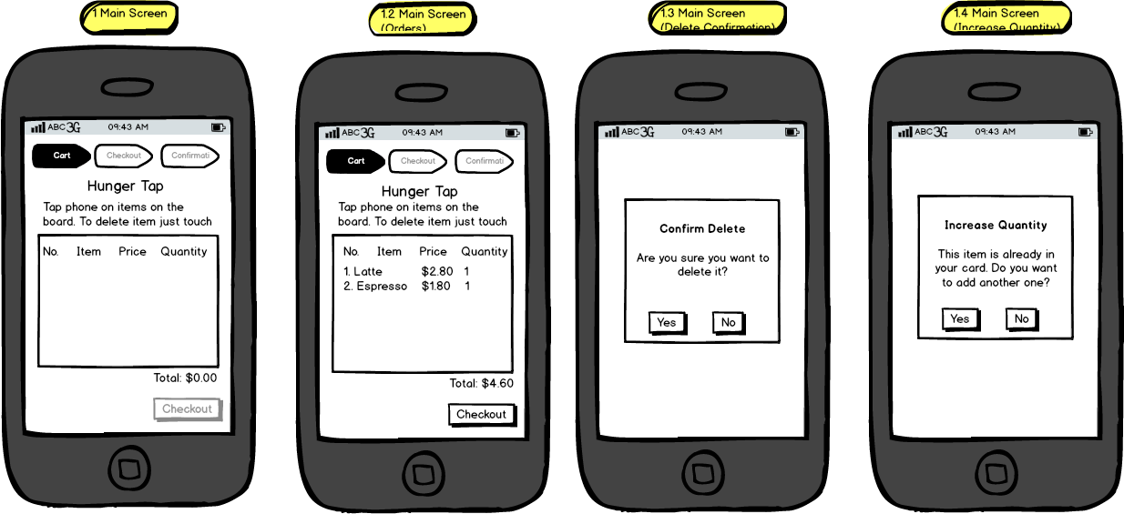

## 

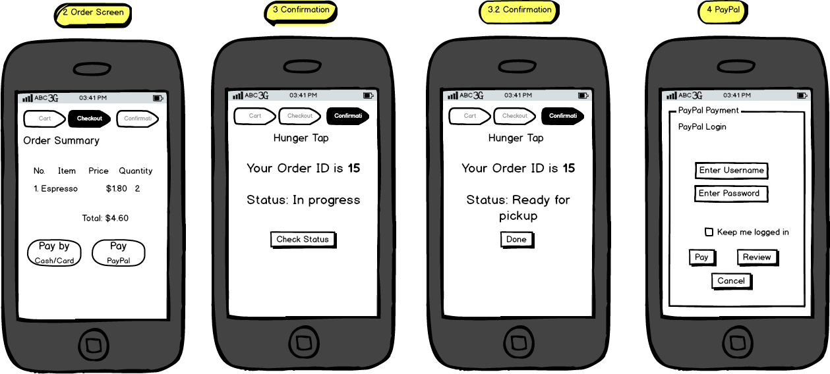

**Admin App**

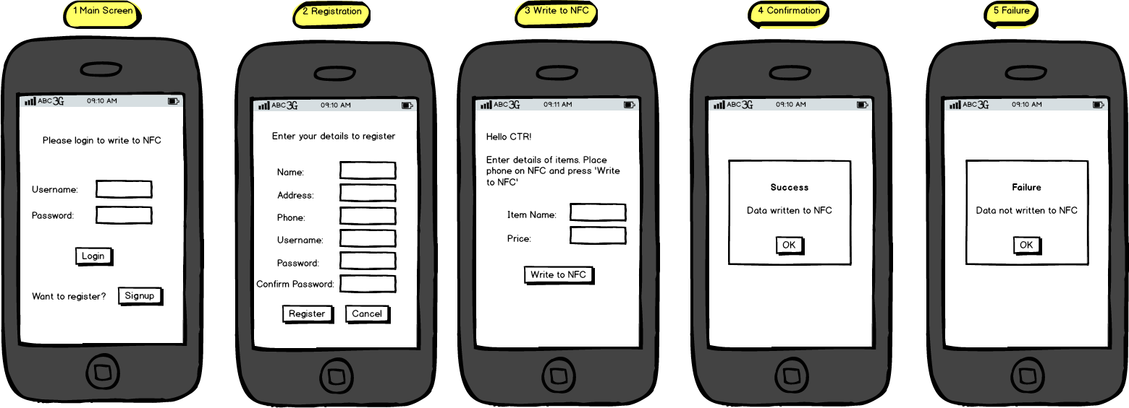

**Web App**

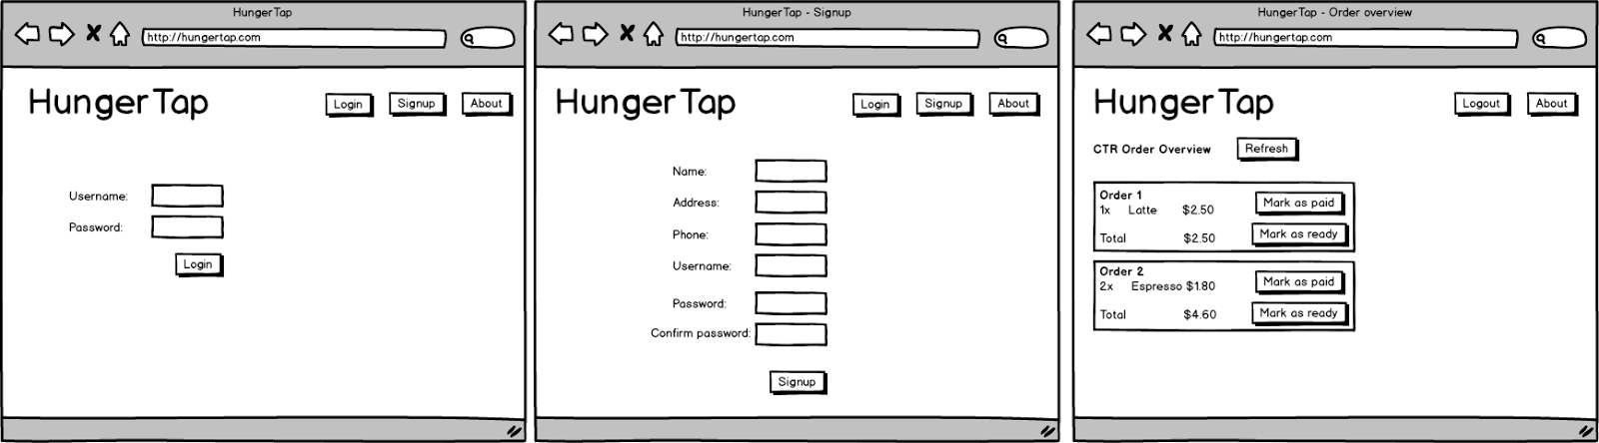

Figure 6: Wireframe diagrams of the HungerTap app, the admin app and the web server

### 4.5 Usability evaluation of the NFC app

After the NFC app was ready, we decided to do a usability evaluation of the app along with the use of a custom made NFC menu board. The following would be the script that we would use during our evaluation. We have tried to be least specific on the terms to understand if users can navigate through our app or not. This time we have the actual NFC based menu board and also the server implemented. Status on the server can be changed to mark as paid or mark as ready.

**Script:**

Open the HungerTap app and choose to order a Latte and an Espresso.

You have changed your mind and want to order two Espresso’s instead.

Complete your order. We have dummy PayPal credentials pre-configured on the app if you choose to pay with PayPal.

Questions to ask post interview:

1. Would you like to use this application regularly?

2. Do you think this app would be useful for you while ordering at your local food joint?

3. Are you concerned about any security or privacy issues associated with this app?

For the sake of brevity, only an overall status of execution of the script is mentioned along with any feedback given by the interviewee.

**Interviewee #1:** Male student aged about 26 years. He is a smartphone user for 4 years.

**Overall status:** User performed all tasks correctly.

**Answers to Questions:**

1. Would you like to use this application? – Yes.

2. Do you think this app would be useful for you while ordering? - Yes, the user found it fast and convenient. He said that he could finish ordering in less than 30 seconds.

3. Are you concerned about any security or privacy issues associated with this app? – Not really, as long as the user’s PayPal payment was encrypted, he was not worried about anything else.

(Note: The PayPal payment is encrypted in our prototype)

**Feedback:** The “Check status” button made the user feel at times that it was not working. Since it takes time for the order to be prepared, when the user clicks on “Check status” while the order is still in progress, the status text does not change. The user felt the button may not be working.

**Rectification:** A current timestamp was included in the status text which would change every time the user clicked the check status button but the status had not changed. The button changed to a different color when it was pressed down and changed back to its original color when released. So a color change indicated that the application has not hung. We are considering replacing this feature with push notifications in the second half of the semester.

**Interviewee #2**

**Description of user:** Male student aged about 23 years. He is a smartphone user for 1 year.

**Overall status:** User performed all tasks correctly.

**Answers to Questions:**

1. Would you like to use this application? - Yes

2. Do you think this app would be useful for you while ordering? - Yes. The user found this idea as something new.

3. Are you concerned about any security or privacy issues associated with this app? - No

**HungerTap ADMIN App**

The script for evaluating the admin app is very simple. It was a one line instruction which said -

Open the HungerTap admin app and write details of Latte costing $2.80 on to the NFC.

Questions to ask post interview:

1. Did you find this application easy to use?

2. Are you concerned about any security or privacy issues associated with this app?

**Interviewee #1**

**Description of user:** Male student aged 30 years. She is a smartphone user for about 5 years now.

**Interview description:**

HungerTap: Open the HungerTap admin app and write details of Latte costing $2.80 on to the NFC.

User Action: User opens the app and clicks on the sign up button. The user then inputs all the required details and clicks on register. The user is taken to the screen where he has to type the item name and price. He types in the name and price and places the phone on the NFC and then presses on “Write to NFC”. Unfortunately the user had not placed the phone properly on the NFC and a Toast message appears that the “Data was not written to the NFC”. The user re-tries again and this time a popup appears that the data was successfully written.

**Feedback:** The user felt that the Toast message could easily be missed and suggested that we create a popup if the data does not get written properly as well. The user also suggested having some sort of help showing users how to place the phone on the NFC.

**Rectification:** A popup was created when the data was not written on the NFC. Also, a help menu option was introduced indicating how the user has to place the phone on the NFC.

**Answer to questions:**

1. Did you find this application easy to use? – Yes, the user found it easy enough for even a technologically challenged person to use.

2. Are you concerned about any security or privacy issues associated with this app? – As long as all my details are encrypted and sent to the server, there should be no issue.

(Note: In the prototype only the password is encrypted)

## 4.6 Detailed Design

## 4.6.1 Customer App

#### **Item Selection- NFC App**

#### 

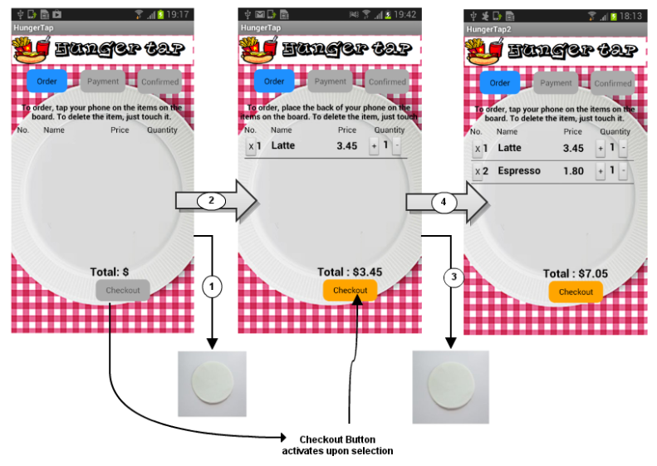

**Item Selection**

In order to select the item, user has to switch on the app or bring it to the foreground. Once the app is in the foreground the user has to tap the phone on the items he needs, to add to the order list. The figure above shows how the order screen gets updated as the user selects new item by tapping on different items (shown as NFC chips).

**Item Selection- QR App**

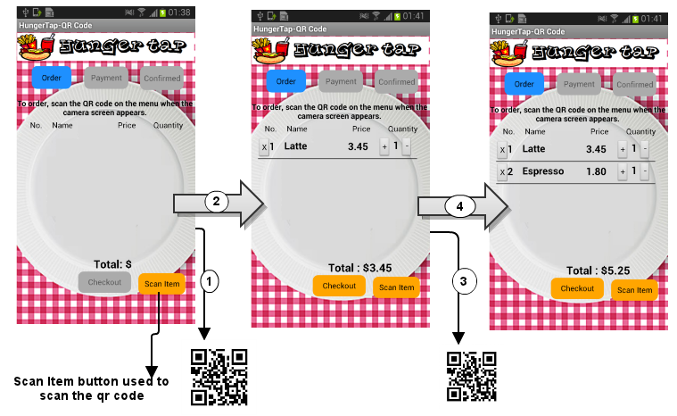

In order to select the item, user has to switch on the app. Once the app is in the foreground, the user has to press the “Scan Item” button to scan the QR-Code of the item he needs to add to the order list. Upon successful scan, the control returns to the original screen with the item being added in the ordered list. The figure above shows how the order screen gets updated as the user selects new items by scanning the QR-Codes.

#### **Assisting User to Select Item – NFC App:**

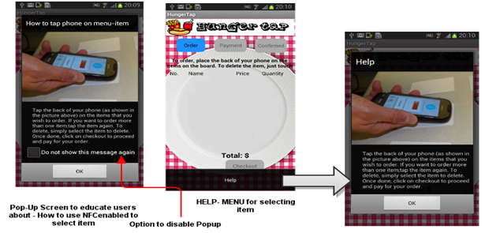

As mentioned in the user study section, we found out that users do not know how to tap the phone to select the item. To help such users, an instruction screen pops up whenever the app comes to the foreground. It explains to the users how to use the phone to make the selection. It not only provides textual help but also explains via means of a picture. The popup could be disabled by the user by clicking on the checkbox. Once checked the popup will not appear whenever the app comes to the foreground. If user still wants to see the instructions sometime later, he or she could select the help menu item to go through the instructions. This way we not only help the users when they first start the app but also assist them later on if needed.

#### **Assisting User to Select Item – QR App:**

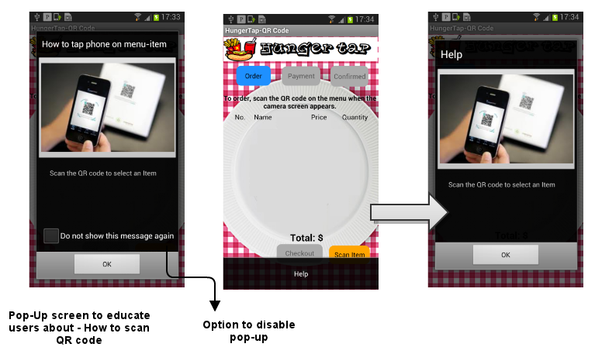

Just like in NFC version of the app, an instruction screen pops up whenever the QR code version of the app comes to the foreground. It explains to the users how to use the phone to make the selection. This popup could be also be disabled by the user by clicking on the checkbox as explained above.

#### **Selecting same item twice- NFC App**

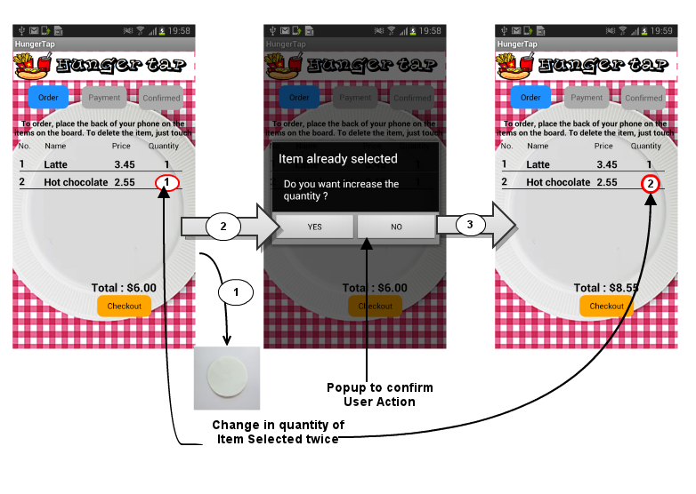

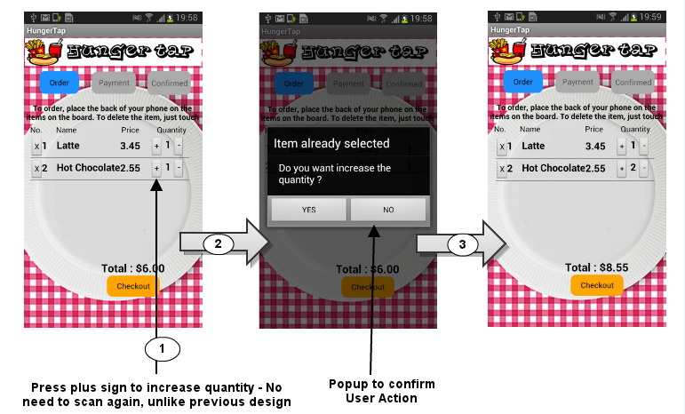

~~Whenever the user wants to increase the quantity of an already selected item, he or she has to tap on the item again. Whenever the user taps on the item and if the item is already present on the order list, a popup screen appears on the main screen asking the user to confirm the action. Once the user confirms the selection, the quantity of the selected item is incremented by one as shown in the figure above. The popup screen was put in place because we found that sometimes new users tap on the same item more than once by mistake even though they actually want to select it only once~~.

#### **Selecting same item twice- QR App**

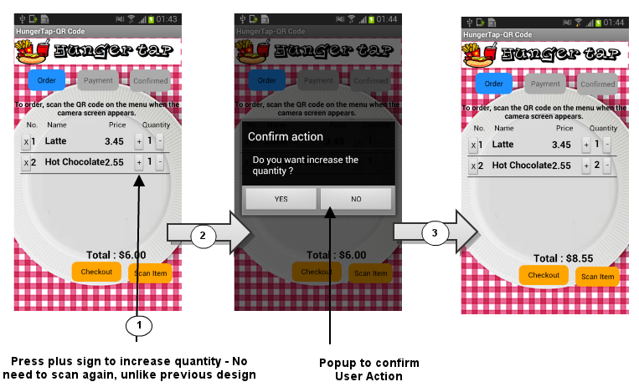

Unlike in previous version where user had to select the item twice to increase the quantity, in the new version we added “+” and “-” buttons to increase and decrease the quantity. This feature was added to improve the usability of the app. It prevents user from scanning the item twice or tapping the phone twice. This feature allowed us to use to the similar order list across different technologies used for selecting an item i.e. NFC and QR-Codes. Once the user presses either “+” or “-” button a popup appears on the screen to confirm the user action. This was added to prevent users from increasing or decreasing quantity accidently. The user can still tap the phone again or scan the item again to increase the quantity.

#### 

#### **Deleting the selected item from the menu:**

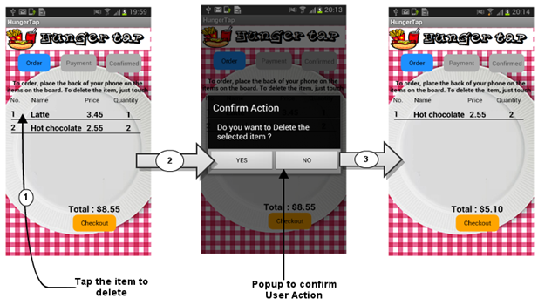

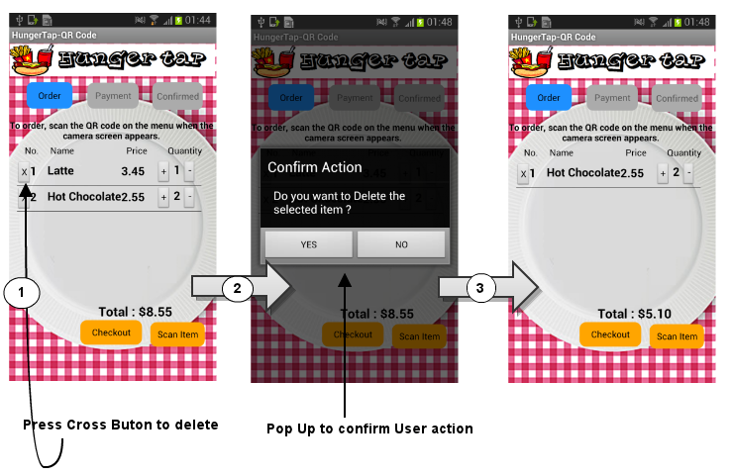

The common way to delete any item on the android phones is to select the item using the press action. We also followed the same convention. In order the delete the item the user to press the corresponding item. Once pressed the popup screen appears asking for confirmation of the user action. Again, this popup is required to prevent unintentional deletions of the items by pressing onto the items in the list. Besides, whenever the item is deleted the serial number is updated accordingly. The figure above shows the sequence of the order screens when an item is deleted.

We provided an additional option for users to delete items. The user has to press the “X” button against the corresponding item. Once pressed the popup screen appears asking for confirmation of the user action.

***Checkout Page:***

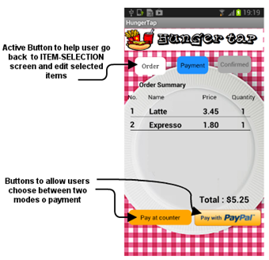

Upon clicking on the checkout button on the order screen the app moves onto the payment screen. This screen displays the final order list and the total amount which the customer has to pay the vendor to complete the transaction. Even after reaching this screen the customer can make new selection. If the customer makes new selection by tapping onto the item, previous activity / screen is restored with recently tapped item being added to the list. The user can also go back to the order screen by clicking on the Order button, if he or she wants to edit the order summary. Once the user is sure about the selection, the user can either pay via existing PayPal account or can pay at counter. Details of both modes of payment are explained below.

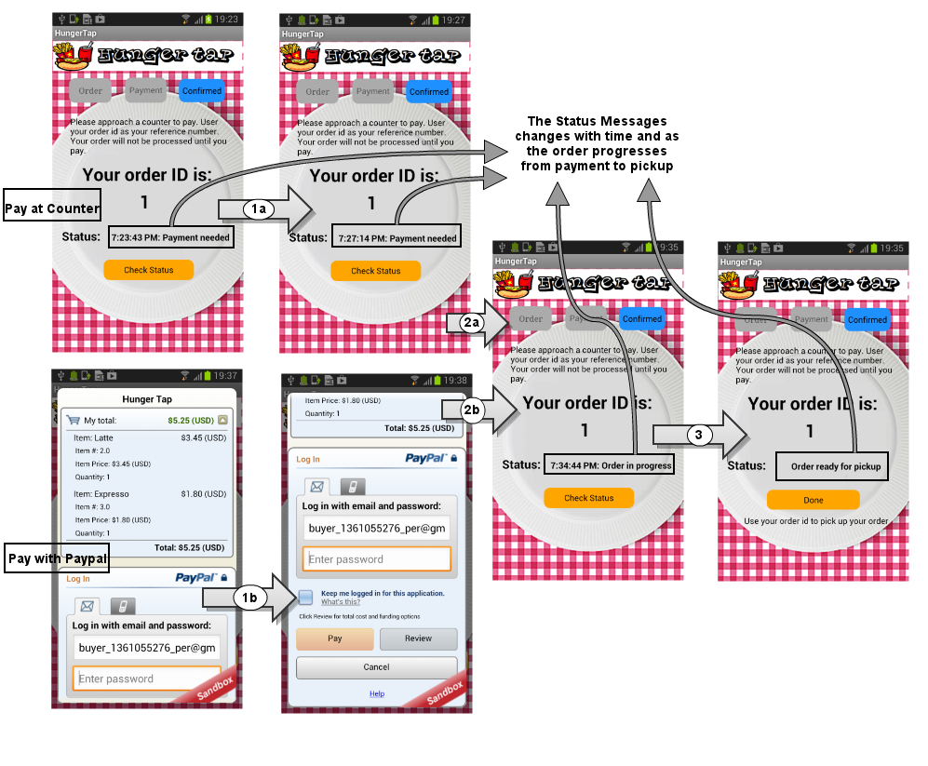

As mentioned above, the user can pay either via PayPal or can pay at the counter. If the user selects to pay by PayPal option, the control goes to the PayPal API. All the user inputs from here-on till the payment is successfully made are handled securely by the PayPal API. Since the app is using PayPal API which handles sensitive user input, security issues will not creep up. Once the user reaches the PayPal activity, the top part of screen displays the order details. The user is expected to scroll down (1b) to make the payment.

If the user selects to pay at the counter the control reaches confirmation screen where the status reads as “payment needed” as shown in the figure above. Upon selecting the ‘Check Status’ the displayed time refreshes, if the payment is still pending (Shown by transition 1b in the above figure).

Once the customer successfully makes the payment either at the counter or via PayPal, Confirmation screen with “order in progress” status message appears in the foreground. ~~If the user continues to press check status even when order is not ready the only thing which changes in the status message, is current time. This was done in order to hint users that app is still waiting for the order to be prepared and is not hung. This change was made after conducting a user study as mentioned in the sections above.~~

**Push Notifications:**

All status updates such as updates on payment receipt or when the order is ready are provided with the help of push notifications to the user. The push notifications are implemented using Google Cloud Messaging for Android. Google Cloud Messaging for Android (GCM) is a service that allows us to send data from the server to the users' Android-powered device.

**How to use Google GCM**

A Google API project has to be created and GCM service has to be enabled in it. The project is used to obtain an API key for the HungerTap server.

In the android app- include the gcm.jar, the required permissions and a broadcast receiver. The broadcast receiver is responsible to handle 2 intents sent by GCM which are the RECEIVE and REGISTRATION intents. Also implement the GCM callback methods such as onRegistered, onUnregistered, onMessage, etc.

When the app is first installed on the phone, GCM assigns a unique ID to the device. This unique ID, the phone account and the server API key is sent to the server in order to allow the server to send device specific messages. The phone account is also associated with every order made in order to identify the device that should receive messages associated with the order.

On the server side, a servlet was created to handle all registrations and de-registrations and mapping phone accounts to the unique ID associated with GCM. This mapping helped in sending order status messages to single devices. Once the restaurant staff clicked on “Mark paid” or “Mark ready” a push notification is immediately sent out to the customer associated with that order.

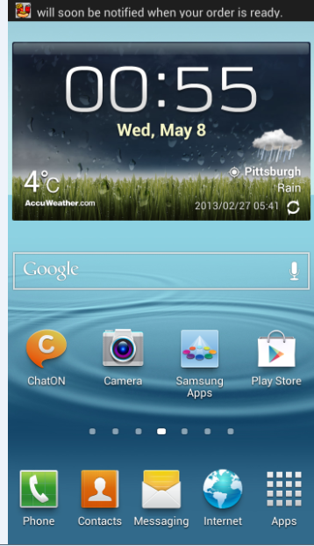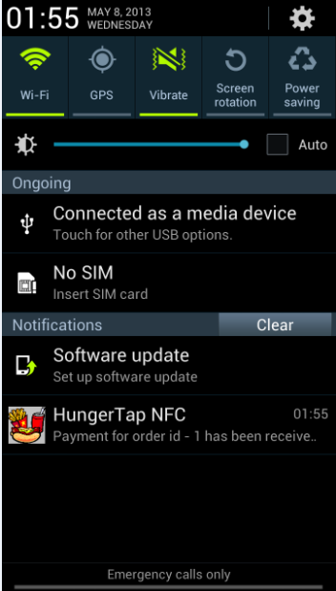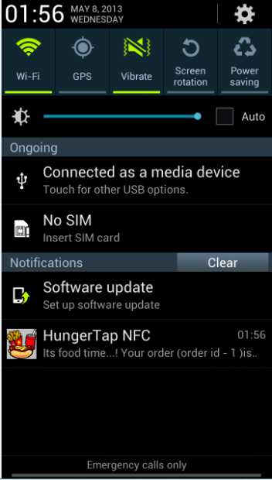

Order is ready

Payment received

The pictures above show notifications. Two notifications are sent. One notification is sent when a payment has been received at the counter and another one when the order is ready.

Also, a check Status button has been provided for the user. This button can also be used to check the status of their order. This is for customers who feel that the notifications could have been missed or are curious just to know their order status. . If the user continues to press check status even when the status has not changed the only thing which changes in the status message, is current time. This was done in order to hint users that app is still waiting for the any update of status and is not hung. This change was made after conducting a user study as mentioned in the sections above.

#### 

#### **Checkout Help Page:**

We have provided a help menu item for the checkout screen. This help menu explains the different payment options. This help menu was added after conducting the user study. It assists new users to get acquainted with the app and its various functionalities. We have purposely kept different help screens for different activities to help new users.

#### 

#### **Confirmation Help page:**

We have also provided separate help menu for the confirmation screen. It explains the importance of the order id to the users. It also explains the next steps a customer has to take if he or she has selected pay at counter option. Thus we have provided help menu for each activity involved during the course of placing new order. During the user study we found out that adding help menu at each stage improves user satisfaction.

### 4.6.2 Admin App

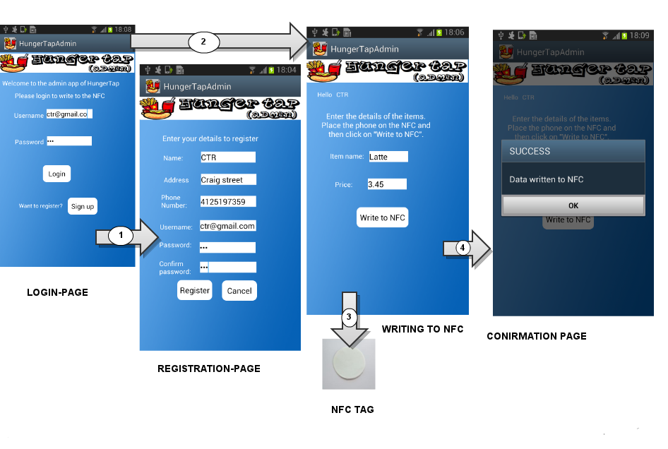

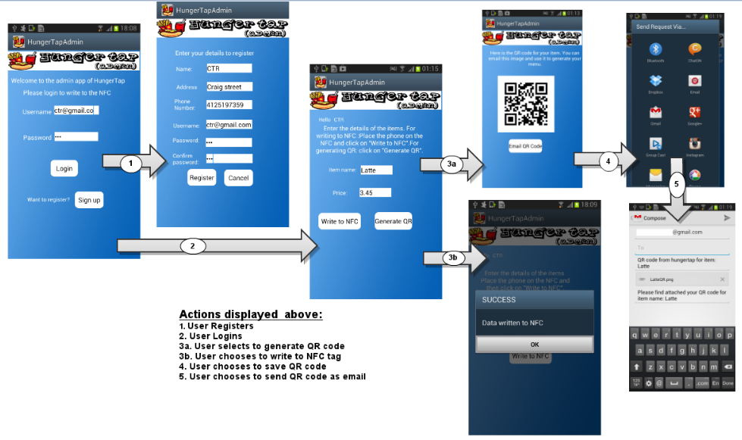

To write on the NFC tags, the vendor has to buy the NFC tags and use the admin app to write the data onto them. Before the vendor is able to write on the tags, he or she has to register to use our service. Once registration is complete the app moves to next screen where the vendor can enter item detail and press the ‘Write to NFC’ button while the NFC tag is touching the back of the phone. Along with writing the user data, the app also writes meta data like unique location id, unique item id, etc. which is required by the web server when customers use the client app. Once the data is successfully written, a popup appears which informs users telling him or her whether data was written on the NFC tag.

To generate QR codes for the items, the idea is pretty similar. Once the vendor has registered with us, he can input the item name and price and click on “Generate QR”. A QR code is generated which can then be emailed to the vendor to be used for creating the menu.

### 4.6.3 Web Interface to Manage Orders

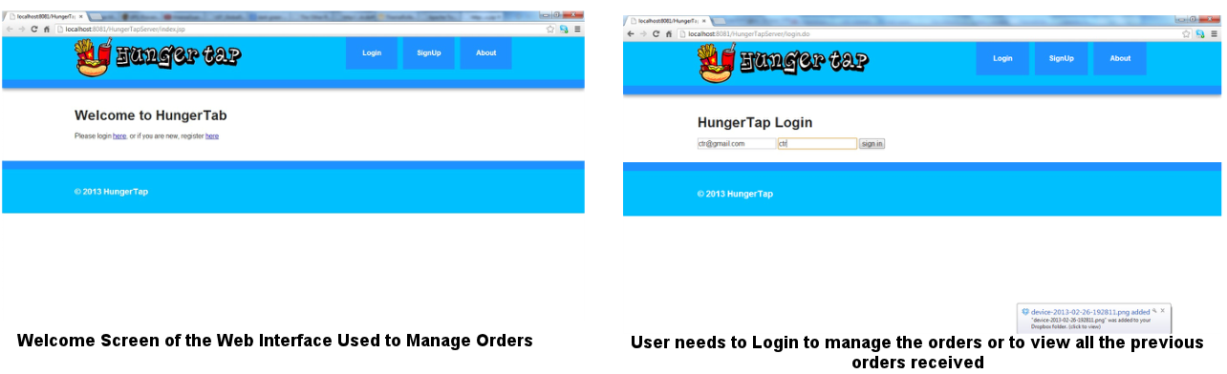

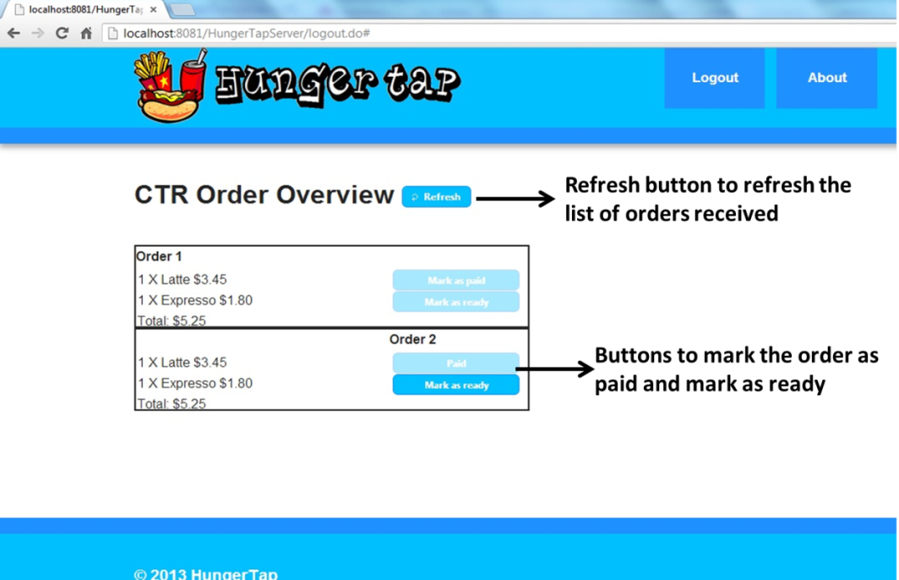

We have provided a web interface for the vendor to manage orders. In order to manage the orders, the vendor has to login using his or her credentials. Each login credential gets a unique location id which is written on the NFC tags and used by the web server to identify which vendor should receive the order. The Order screen displays the orders placed along with two buttons against each order - ‘Paid’/’Mark as paid’ and ‘Mark as ready’. If the customer has selected pay at counter option, then the user is first expected to pay at the counter before the vendor could go ahead and prepare the order. Once paid, the vendor clicks on ‘Mark as paid’ and then processes the order. Once the order is prepared, the vendor marks it as ready, to inform the customer.

We have a polling functionality implemented on the web server which polls the database frequently for new orders based on a timestamp. Hence the vendor need not keep clicking on refresh (though we have also provided this feature if he does not want to wait for the polling).

### 4.6.4 Development tools

* ECLIPSE :

We used eclipse for our android app and web server development. We added an android development plugin to eclipse called MOTODEV studio. We also used DDMS plugin to take phone screenshots.

* NFC Tags :

We used MifareClassic NFC tags. These tags have capacity 1024 KB bytes out which 763 bytes could be written by user.

* Balsimiq :

It was used for creating Mockups of the phone screens.

* Droidraw :

Instead of manually editing the various layout xml files, we used Droidraw for creating phone screens.

* Tomcat, Java Servlets, JSP, Javascript and MySql :

For creating the webserver we used Tomcat for hosting our servlets. We implemented the webserver using MVC architecture. We used Java-beans and DAO for handling MySql database. We used JSP and JavaScript for handling the views.

* SVN :

We used SVN for version control of the whole codebase. It allowed our team to develop the whole ecosystem in a collaborative fashion.

## 4.7 Privacy and security issues

### 4.7.1 User Privacy

For our service we want to follow the FTC’s Fair Information Practices Principles. This starts with a privacy policy that explains to the user what information is stored and how it is used. This policy will be available on our website as well as through the app. For customers this is just the information used to process the order. Currently this does not include any personal identifiable information (PIA). For restaurant owners however we do store their email, address and phone number along with a password. Owners have access to this data, which allows them to modify it as well through our web interface. Both customers as well as owners have the option to opt out by not using our service.

Currently we do keep order information in the database. This policy has to be reviewed before launching the app. We should not keep the information indefinitely, but as order information can be valuable for future service offerings, the terms of service should allow us to keep this information for a reasonable amount of time. Possibly the user information could be anonymized after a certain period of time.

### 4.7.2 Security Considerations

We will ensure that data is secure by using encrypted transmission between the app and the server (not completely implemented in the prototype), as well as storing the data in secured databases. Before launching the app, we will also put in place mechanisms that’ll handle security issues.

In addition to transmitting the data securely, the control data stored in the tags should also be encrypted/hashed, so that the tags can’t be manipulated or reproduced by a third party.

When using QR codes, it is possible for a malicious attacker to take a picture of the codes and create bogus orders or launch a large number of orders. This is only a secondary thread, since the restaurants won’t start processing the orders until the payment was received either through PayPal or in person. However the restaurant dashboard could be flooded with these requests. Since the requests include the account information of the sender we can restrict the number of concurrent orders on a per user basis, or completely block a user from sending requests (to be implemented).

### 4.7.3 App Permissions

When a user downloads one of our apps they have to allow the following permissions for it during the installation process to work properly.

**Customer App**

* READ_PHONE_STATE - Allows read only access to phone state: This permission is required to access to basic information such as phone type, network state or phone number.
* ACCESS_WIFI_STATE - Allows applications to access information about Wi-Fi networks: This permission is required to have the app work over wi-fi.
* NFC - Allows applications to perform I/O operations over NFC: This permission is required to access the NFC reader. (NFC App only)
* C2D_MESSAGE - prevents other applications from registering and receiving the application's messages: This permission is required to send and receive push notifications.
* INTERNET - Allows applications to open network sockets: This permission is required to let the app access the web servers.
* GET_ACCOUNTS - Allows access to the list of accounts in the Accounts Service: This permission is required to get the phone account which is required for the push notification.
* WAKE_LOCK - Allows using PowerManager WakeLocks to keep processor from sleeping or screen from dimming: This permission is required to keep the phone from sleeping during certain app screens.
* CAMERA – Allows app to open the camera to scan the QR code (QR App only). Auto-focus, front camera and flash of camera are disabled when using the camera with the QR code app.

**Hunger Tap Admin App**

* READ_PHONE_STATE - Allows read only access to phone state: This permission is required to access to basic information such as phone type, network state or phone number.
* INTERNET - Allows applications to open network sockets: This permission is required to let the app access the web servers.
* ACCESS_WIFI_STATE - Allows applications to access information about Wi-Fi networks: This permission is required to have the app work over wi-fi.
* WRITE_EXTERNAL_STORAGE - Allows an application to write to external storage: The QR code is written onto a file and then mailed to the user. So to write to file we need this permission.
* NFC - Allows applications to perform I/O operations over NFC: This permission is required to access the NFC writer.

## 4.8. Future Development

~~In our prototype we focused on a MVP, which purposely left out a number of features. Before adding these features we want to study the feasibility of our NFC approach by testing alternative ways of automating food ordering.~~

~~We are also considering using push notifications instead of making the user check for the status regularly.~~

~~In addition, the web app needs to be improved for tablet usability, to allow it to be used on cheaper tablets compared to full-fledged laptops at the restaurants.~~

The web app should be improved to allow shop owners a way to create menus and print them themselves. This is an easy and cheap way for them to update their menu. We can provide a variety of menu templates, so that owners just need to enter their menu and price information and optionally upload pictures for their items.

# 5. Conclusion and Learning

The motivation for HungerTap was to enable users to order quickly in an efficient and convenient manner. There was a lot of learning all through the development of the prototype. Not only did we learn new technologies but we also learnt from user surveys and prototype evaluation. The survey played a key role in helping us make design decisions about the app. The business aspects were also thought about while making choices of the best way to do things.

The current prototype version did allow for convenient ordering. We will evaluate other methods and identify how we can improve user convenience even more during the second half of the course.

# 6. Appendix

## A. Menu Board Prototype

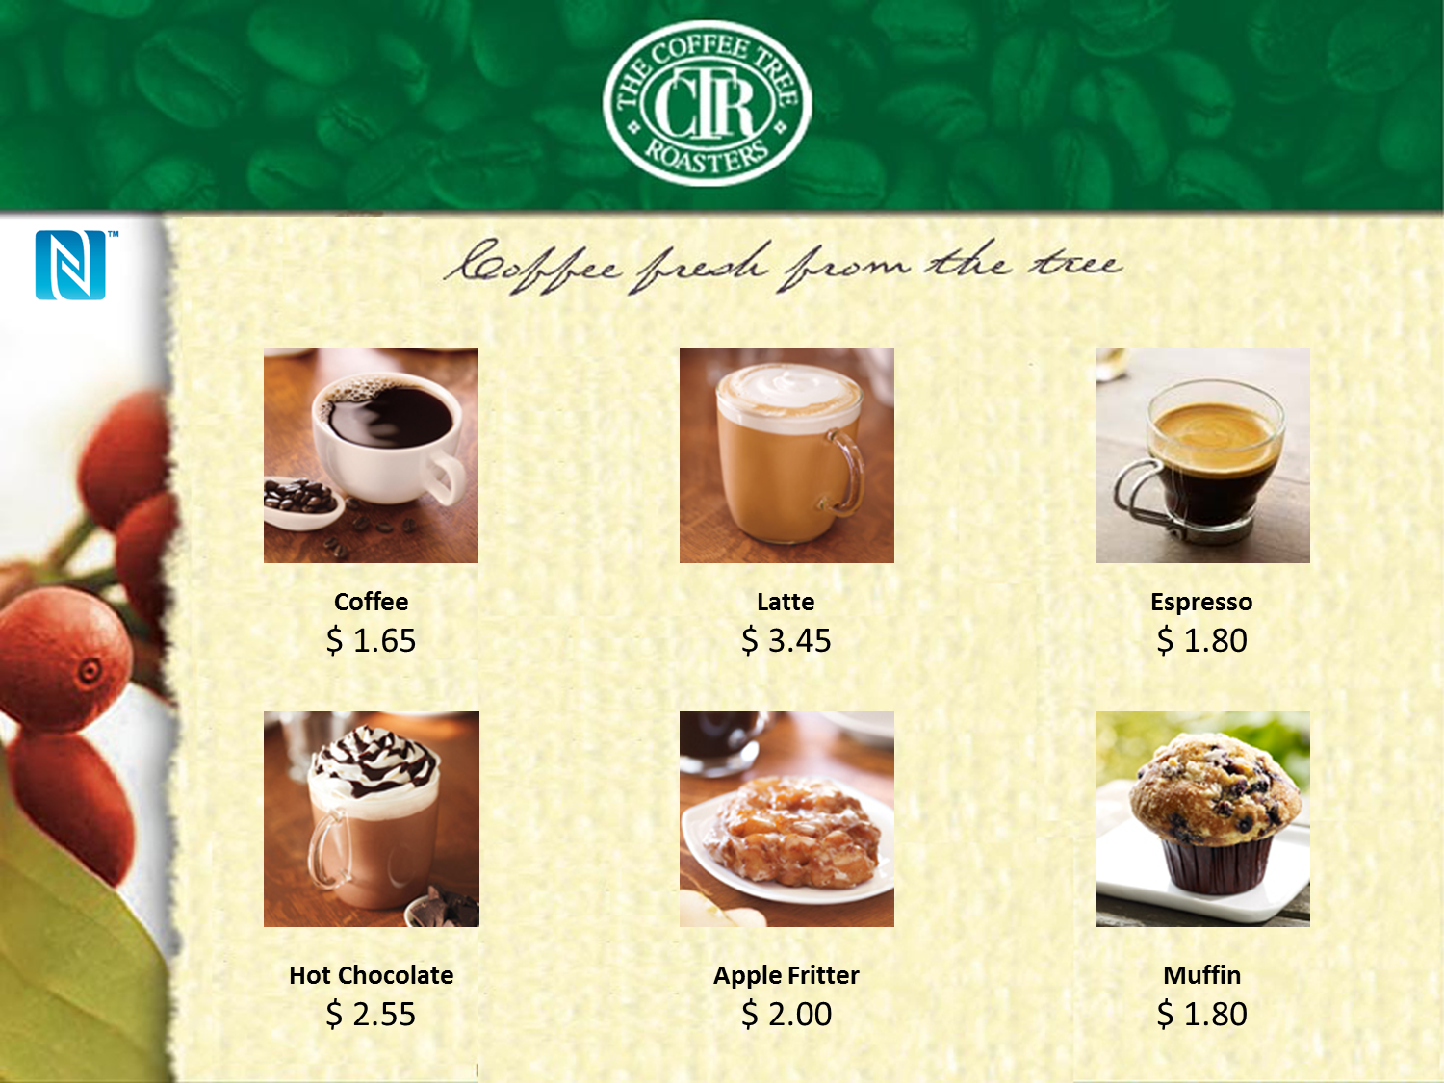

A sample menu board is shown above. NFC tags can be attached to the back of the pictures.

## B. QR Menu Board Prototype

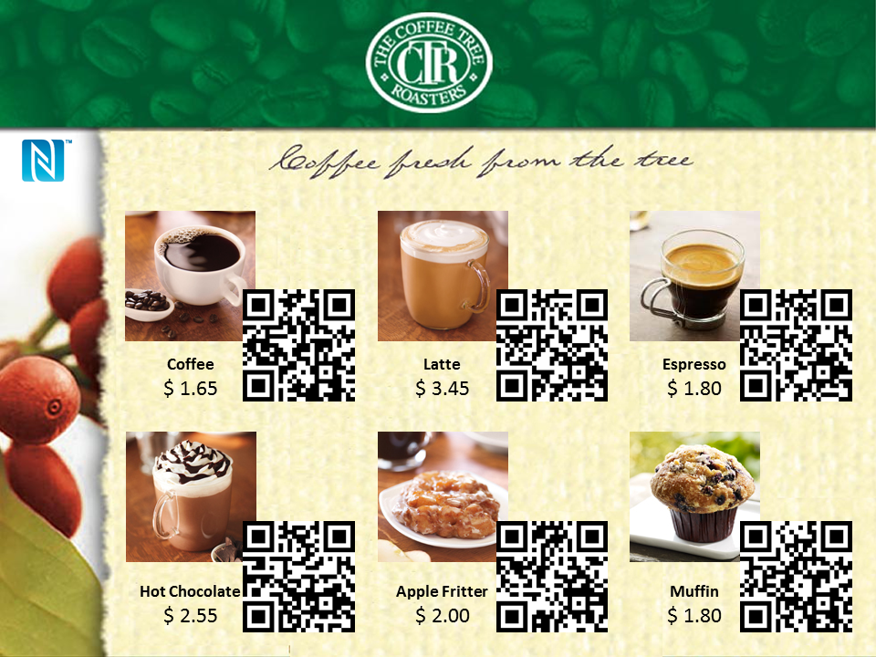

1. IBISWorld Industry Report 72221a, Fast Food Restaurants in the US, February 2013
2. IBISWorld Industry Report 72221b, Coffee & Snack Shops in the US, December 2012
3. IBISWorld Industry Report 44511, Supermarkets & Grocery Stores in the US, April 2013
4. http://archive.is/20120906/http://www.internetretailing.net/2011/08/14m-americans-scanned-qr-and-bar-codes-with-their-mobiles-in-june-2011/
5. Source: Frost and Sullivan - NFC: When will be the Real Start?
6. Source: Frost and Sullivan - NFC Market Opportunity - Feb 2013